Step 1: Identify Key Entities
From your SRS, the core tables/entities will be:
- User (customers, admins, drivers, staff)
- Company (Tenant) (multi-tenant support for different clients)
- Booking (main transaction between customer & company)
- Service (house shifting, office relocation, etc.)
- Booking_Item (inventory list for a booking)
- Vehicle (fleet info)
- Driver (linked with user + vehicle)
- Payment/Invoice
- Notification (SMS/Email/Push logs)

Step 2: Define Relationships (ER Diagram)
- Company ↔ User (One company has many users; each user belongs to one company).
- User ↔ Booking (Customer creates many bookings).
- Booking ↔ Booking_Item (One-to-many).
- Booking ↔ Driver (One driver per booking, optional at creation).
- Booking ↔ Payment/Invoice (One-to-one).
- Driver ↔ Vehicle (One driver can be linked to one vehicle).
- Booking ↔ Notification (One-to-many).

Step 3: ER Diagram (to visualize)
Do you want me to start with a clean ER diagram first (visual only) OR give you the SQL schema (PostgreSQL DDL) along with the diagram?

Yes

from graphviz import Digraph

# Create a new directed graph for ER Diagram
er = Digraph('PackersMoversERD', filename='packers_movers_erd.gv', format='png')
er.attr(rankdir='LR', size='10')

# Entities with attributes
entities = {
"User": ["user_id (PK)", "full_name", "email", "phone", "password_hash", "role (customer/admin/staff)", "created_at"],
"Booking": ["booking_id (PK)", "user_id (FK)", "pickup_address", "drop_address", "move_date", "status", "created_at"],
"Vehicle": ["vehicle_id (PK)", "vehicle_number", "type", "capacity", "status"],
"Staff": ["staff_id (PK)", "full_name", "phone", "role", "assigned_vehicle_id (FK)", "status"],
"Payment": ["payment_id (PK)", "booking_id (FK)", "amount", "payment_method", "payment_date", "status"],
"Service": ["service_id (PK)", "service_name", "description", "base_price"],
"Quotation": ["quotation_id (PK)", "booking_id (FK)", "estimated_cost", "status", "valid_until"],
"Feedback": ["feedback_id (PK)", "user_id (FK)", "booking_id (FK)", "rating", "comments", "created_at"]
}

# Add entities
for entity, attrs in entities.items():
label = f"{entity}|{'|'.join(attrs)}"
er.node(entity, shape="record", label=label)

# Relationships
relationships = [
("User", "Booking", "1..*", "Places"),
("Booking", "Payment", "1..1", "Has"),
("Booking", "Quotation", "1..1", "Generates"),
("Booking", "Service", "M..N", "Includes"),
("Booking", "Staff", "M..N", "Assigned"),
("Vehicle", "Staff", "1..*", "OperatedBy"),
("User", "Feedback", "1..*", "Gives"),
("Booking", "Feedback", "0..1", "ReviewedBy")
]

# Add edges with labels
for src, dst, card, rel in relationships:
er.edge(src, dst, label=f"{rel}\n({card})")

# Render the diagram
file_path = er.render(directory='/mnt/data')
file_path

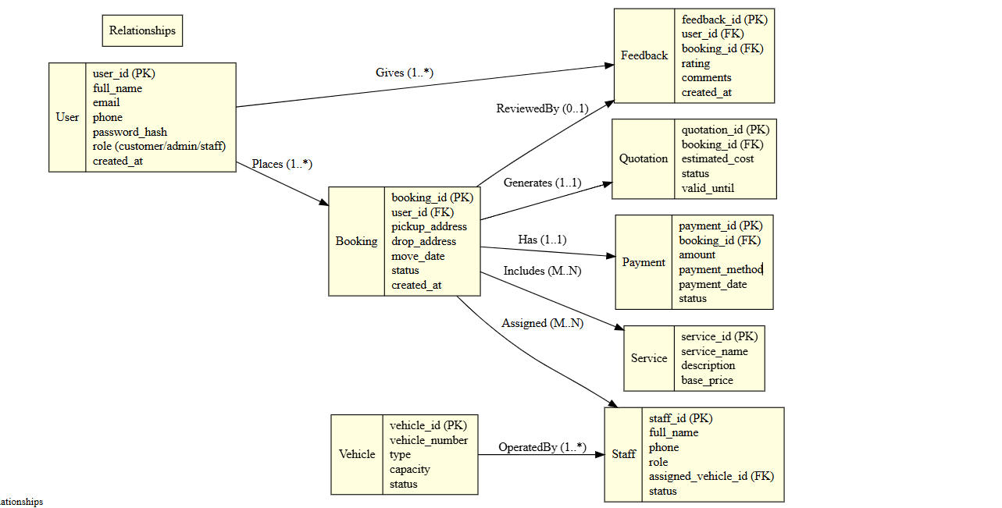
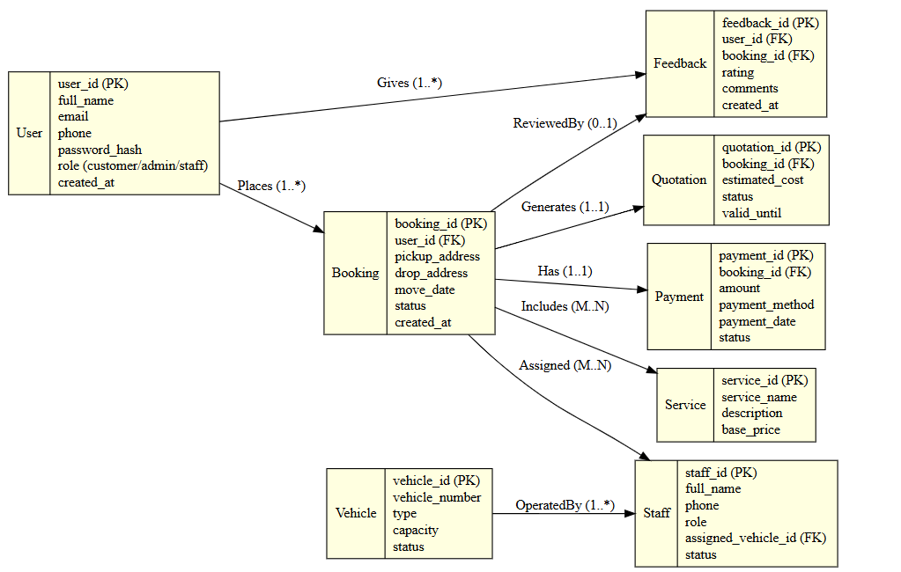

🔑 What changes in Multi-Tenant Design?
We add a Company (Tenant) entity:
- company_id (PK)
- company_name
- address
- contact_email
- subscription_plan
- created_at
Then we link:
- Company → Users (each user belongs to one company)
- Company → Bookings (each booking belongs to one company)
- This way, data is isolated per company, but your software stays single-instance.
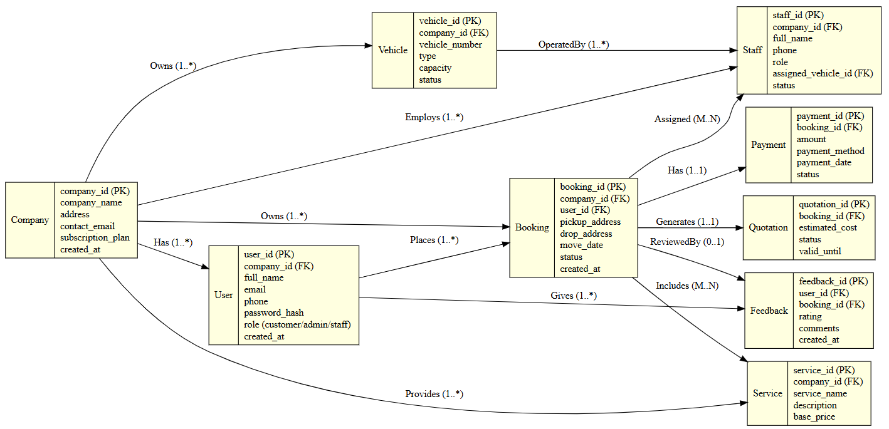

This extended version ensures:
- Each Company (Tenant) has its own users, vehicles, staff, and services.
- Still scalable → you can run one app for multiple businesses.

-- ==========================
-- Multi-Tenant Packers & Movers DB Schema
-- ==========================

-- Company (Tenant)
CREATE TABLE company (
company_id SERIAL PRIMARY KEY,
company_name VARCHAR(100) NOT NULL,
address TEXT,
contact_email VARCHAR(100) UNIQUE,
subscription_plan VARCHAR(50),
created_at TIMESTAMP DEFAULT CURRENT_TIMESTAMP
);

-- Users (Customers, Admins, Staff)
CREATE TABLE app_user (
user_id SERIAL PRIMARY KEY,
company_id INT REFERENCES company(company_id) ON DELETE CASCADE,
full_name VARCHAR(100) NOT NULL,
email VARCHAR(100) UNIQUE NOT NULL,
phone VARCHAR(20) UNIQUE,
password_hash TEXT NOT NULL,
role VARCHAR(50) CHECK (role IN ('customer','admin','staff','driver')),
created_at TIMESTAMP DEFAULT CURRENT_TIMESTAMP
);

-- Vehicles
CREATE TABLE vehicle (
vehicle_id SERIAL PRIMARY KEY,
company_id INT REFERENCES company(company_id) ON DELETE CASCADE,
vehicle_number VARCHAR(20) UNIQUE NOT NULL,
type VARCHAR(50),
capacity INT,
status VARCHAR(20) DEFAULT 'available'
);

-- Staff (separate from app_user for detailed info)
CREATE TABLE staff (
staff_id SERIAL PRIMARY KEY,
company_id INT REFERENCES company(company_id) ON DELETE CASCADE,
full_name VARCHAR(100) NOT NULL,
phone VARCHAR(20) UNIQUE,
role VARCHAR(50),
assigned_vehicle_id INT REFERENCES vehicle(vehicle_id),
status VARCHAR(20) DEFAULT 'active'
);

-- Services (House Shifting, Office Relocation, etc.)
CREATE TABLE service (
service_id SERIAL PRIMARY KEY,
company_id INT REFERENCES company(company_id) ON DELETE CASCADE,
service_name VARCHAR(100) NOT NULL,
description TEXT,
base_price NUMERIC(10,2) NOT NULL
);

-- Bookings
CREATE TABLE booking (
booking_id SERIAL PRIMARY KEY,
company_id INT REFERENCES company(company_id) ON DELETE CASCADE,
user_id INT REFERENCES app_user(user_id) ON DELETE SET NULL,
pickup_address TEXT NOT NULL,
drop_address TEXT NOT NULL,
move_date DATE NOT NULL,
status VARCHAR(20) DEFAULT 'pending',
created_at TIMESTAMP DEFAULT CURRENT_TIMESTAMP
);

-- Booking ↔ Service (M:N relationship)
CREATE TABLE booking_service (
booking_id INT REFERENCES booking(booking_id) ON DELETE CASCADE,
service_id INT REFERENCES service(service_id) ON DELETE CASCADE,
PRIMARY KEY (booking_id, service_id)
);

-- Payments
CREATE TABLE payment (
payment_id SERIAL PRIMARY KEY,
booking_id INT UNIQUE REFERENCES booking(booking_id) ON DELETE CASCADE,
amount NUMERIC(10,2) NOT NULL,
payment_method VARCHAR(50),
payment_date TIMESTAMP DEFAULT CURRENT_TIMESTAMP,
status VARCHAR(20) DEFAULT 'pending'
);

-- Quotations
CREATE TABLE quotation (
quotation_id SERIAL PRIMARY KEY,
booking_id INT UNIQUE REFERENCES booking(booking_id) ON DELETE CASCADE,
estimated_cost NUMERIC(10,2) NOT NULL,
status VARCHAR(20) DEFAULT 'pending',
valid_until DATE
);

-- Feedback
CREATE TABLE feedback (
feedback_id SERIAL PRIMARY KEY,
user_id INT REFERENCES app_user(user_id) ON DELETE SET NULL,
booking_id INT REFERENCES booking(booking_id) ON DELETE CASCADE,
rating INT CHECK (rating BETWEEN 1 AND 5),
comments TEXT,
created_at TIMESTAMP DEFAULT CURRENT_TIMESTAMP
);

Key Features
- Multi-Tenant Ready → every entity is linked to company_id.
- User Roles → handled in app_user.role.
- M:N Relationship → booking_service handles multiple services per booking.
- Data Isolation → if a company is deleted, all its users/bookings/services cascade.
-- ==========================
-- Sample Data for Packers & Movers
-- ==========================

-- Companies
INSERT INTO company (company_name, address, contact_email, subscription_plan)
VALUES
('Sharma Packers & Movers', 'Jaipur, Rajasthan', 'contact@sharmapackers.com', 'Premium'),
('Gupta Relocations', 'Delhi, India', 'info@guptarelocations.com', 'Basic');

-- Users
INSERT INTO app_user (company_id, full_name, email, phone, password_hash, role)
VALUES
(1, 'Amit Sharma', 'amit@sharmapackers.com', '9876543210', 'hashedpwd1', 'admin'),
(1, 'Rohit Meena', 'rohit@customer.com', '9123456780', 'hashedpwd2', 'customer'),
(1, 'Suresh Yadav', 'suresh@driver.com', '9988776655', 'hashedpwd3', 'driver'),
(2, 'Priya Gupta', 'priya@guptarelocations.com', '8899776655', 'hashedpwd4', 'admin'),
(2, 'Anjali Singh', 'anjali@customer.com', '9001122334', 'hashedpwd5', 'customer');

-- Vehicles
INSERT INTO vehicle (company_id, vehicle_number, type, capacity, status)
VALUES
(1, 'RJ14-AB-1234', 'Truck', 3000, 'available'),
(1, 'RJ14-CD-5678', 'Mini Truck', 1200, 'in_use'),
(2, 'DL10-XY-9988', 'Truck', 3500, 'available');

-- Staff
INSERT INTO staff (company_id, full_name, phone, role, assigned_vehicle_id, status)
VALUES
(1, 'Manoj Kumar', '9812345678', 'Helper', 1, 'active'),
(1, 'Deepak Joshi', '9822334455', 'Driver', 2, 'active'),
(2, 'Rahul Verma', '9911223344', 'Helper', 3, 'active');

-- Services
INSERT INTO service (company_id, service_name, description, base_price)
VALUES
(1, 'House Shifting', 'Shifting household items safely', 5000.00),
(1, 'Office Relocation', 'Complete office relocation service', 10000.00),
(2, 'Vehicle Transport', 'Transporting cars and bikes', 7000.00);

-- Bookings
INSERT INTO booking (company_id, user_id, pickup_address, drop_address, move_date, status)
VALUES
(1, 2, 'Vaishali Nagar, Jaipur', 'Malviya Nagar, Jaipur', '2025-09-25', 'pending'),
(2, 5, 'Connaught Place, Delhi', 'Noida, UP', '2025-09-28', 'confirmed');

-- Booking-Service Mapping
INSERT INTO booking_service (booking_id, service_id)
VALUES
(1, 1), -- Booking 1 includes House Shifting
(2, 3); -- Booking 2 includes Vehicle Transport

-- Payments
INSERT INTO payment (booking_id, amount, payment_method, status)
VALUES
(1, 5500.00, 'UPI', 'completed'),
(2, 7200.00, 'Credit Card', 'pending');

-- Quotations
INSERT INTO quotation (booking_id, estimated_cost, status, valid_until)
VALUES
(1, 5500.00, 'accepted', '2025-09-30'),
(2, 7200.00, 'sent', '2025-09-27');

-- Feedback
INSERT INTO feedback (user_id, booking_id, rating, comments)
VALUES
(2, 1, 5, 'Excellent service, very professional!'),
(5, 2, 4, 'Good experience, but could be faster.');

What You Get
- 2 Companies (tenants) → Sharma Packers & Movers, Gupta Relocations
- Admins, Customers, Drivers with Indian names
- Bookings & Services → House Shifting in Jaipur, Vehicle Transport in Delhi
- Payments, Quotations, Feedback → covers end-to-end flow

